Subjects may be completed in the order you prefer | Reading | Math  (AC Math – Follows Einerston) | Writing | Science/Social Studies
Monday  Make sure you look ahead in the week to see if you can make our virtual meetings! | - Complete “Got Allergies?” Readworks.org task  - Read a chapter book of your choice for at least 20 minutes | - Complete one full session of XtraMath  - Earn a medal or 15min on each of the 3 IXL Skills  U.1, T.11, Free Choice | Every Monday, you will be starting a new writing piece. The goal is to finish it by Friday and share with me. Scroll down to next page for more info. | Your Egg Drop Diagram should be complete. If you can share a picture with me through Seesaw, that’d be great!
Tuesday  11am Zoom Class Meeting  Join Zoom Meeting  https://zoom.us/j/348234918  Meeting ID: 348 234 918 | - Work on Read Theory.org for 20 min  - Read a chapter book of your choice for at least 20 minutes | - Complete 30 minutes of Dreambox  - Earn a medal or 15min on each IXL Skill  S.8, Q.5 | Work on writing | Go to IXL Science or Social Studies and practice for 15 min or earn a medal, whichever comes first. Your choice of skill to practice.
Wednesday  11am Zoom Meeting with Counselors  Join Zoom Meeting  https://zoom.us/j/499752614  Meeting ID: 499 752 614 | - Complete “A New Kind of Library” Readworks.org task  - Read a chapter book of your choice for at least 20 minutes | - Complete one full session of XtraMath  - Earn a medal or 15min on each of the 3 IXL Skills  P.9, O.1, N.1 | Work on writing | Civil War: Road to Secession Chart  - Uncle Tom’s Cabin  - Compromise of 1850  (Scroll down to get Assignment)
Thursday  *Target Students: Complete your Target Classwork instead of today’s assigned work | - Work on Read Theory.org for 20 min  - Read a chapter book of your choice for at least 20 minutes | - Complete 30 minutes of Dreambox  - Earn a medal or 15min on both IXL Skills  M.2, J.2 | Work on writing | Go to IXL Science or Social Studies and practice for 15 min or earn a medal, whichever comes first. Your choice of skill to practice.
Friday  We have class meeting scheduled at 11am on Monday, March 30th. | - IXL Language Arts  Practice for 20 min on the following skills: Text Structure Section D.1, D.2  - Read a chapter book of your choice for at least 20 minutes | - Complete 30 minutes of Dreambox  - Earn a medal or 15min on both IXL Skills  F.7, D.16 | Work on writing and share with Mrs. Smith | Civil War: Road to Secession Chart  - Fugitive Slave Act  - John Brown’s Raid  (Scroll down to get Assignment)

This week you will be writing an Informational Essay. Copy the Graphic Organizer/Planning page onto a sheet of paper and plan your essay. Next, write your essay. Remember your Intro, three paragraphs and a conclusion. Share with me and I will provide you with Conference Notes to help you revise and edit your essay.
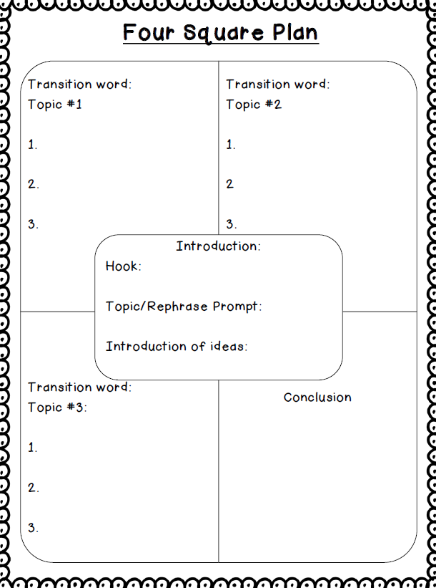

Directions: Copy the chart below and complete by providing a description for each cause in the “what” column and then explain how that cause helped contribute to the outbreak of the American Civil War in the “significance” column. Go to https://kids.britannica.com/ to research.
Road to Secession Chart:
Causes of the Civil War
Cause | What Happened? | Significance?
Uncle Tom’s Cabin
Compromise of 1850
Fugitive Slave Act
John Brown’s Raid
Dred Scott Case
Lincoln’s Election
Attack on Fort Sumter

