Friday, March 20th, 2020

Today, look at the tasks posted starting on Monday. If you didn’t complete some of them, try and complete them today so you are up to speed starting Monday.
Math
Warm Up:
10 min of Xtra Math Fact Fluency Practice or DreamBox – Free Choice Friday!
Lesson Skills:
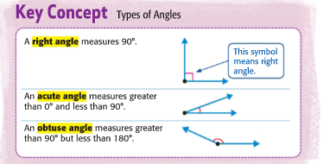
Go to IXL and practice each assigned skill for 15 min or until you get a medal. Whichever you get to first.
Z.1 Intro to Angles: Acute, Right, Obtuse, Straight (New Skill)
T.3 Understanding Decimals in Words (Review Skill - Decimals)
P.18 Compare Fractions (Review Skill - Fractions)

Reading and Writing
- Go on Read Theory for 20 minutes
- Read for 20 minutes (or more) from your own chapter book.

Science
Today your Simple Machines poster that you started on Monday, should be complete. Next, go to https://sciencetrek.org/sciencetrek/topics/simple_machines/games.cfm and explore some of the fun activities on Simple Machines

