Wednesday, March 18th, 2020
Math
Lesson:
https://www.youtube.com/watch?v=PcEwj5_v75g Review on writing fractions in lowest terms
https://www.youtube.com/watch?v=89vsdiRIg3E Review Long Division
Task:
Complete Ch.14 Check Progress pages 885 – 886 (See yesterday’s Math Lesson for videos on these skills)
IXL - earn a medal or work for 15 min in each skill. If you have already completed these skills, choose two other review skills to practice.
P.11 Writing Fractions in Lowest Terms
E.6 Divide 2 Digit Numbers by 1 Digit Numbers
Complete 15 min on DreamBox

Reading and Writing
Lesson:
This week we will focus on Text Structure. Yesterday, you watched a short video to kick off our lesson https://www.youtube.com/watch?v=7kWGQ-_ipBY
Task:
Today, I want you to write using each of the different text structures. See example below:
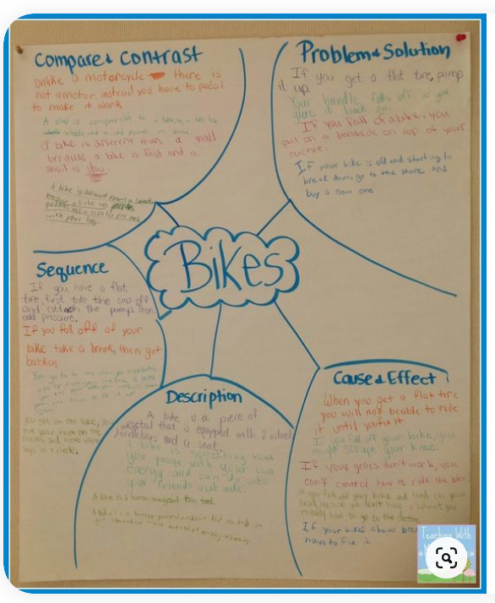
You can complete this task on any topic you’d like. Some ideas are dogs, school, beach, etc.
Read for 20 minutes (or more) your own chapter book

Science
Yesterday, you watched a video on the different Simple Machines. For the rest of the week, I want you to create a poster (any kind of paper you have is fine), a Sway or a Power Point of each of the 6 Six Simple Machines. I have included a Simple Machines Chart to help guide the expectations of this project.

